Alexander Baldree

2/12/26

Module 6.3 Assignment

CSD340

**BioSite- Tyler Bettis**

**GitHub Link:**

[**https://github.com/Panda-Alex21687/BioSite**](https://github.com/Panda-Alex21687/BioSite)

**Welcome Page: Tyler’s Meet him**

**About Tyler: Really trying to get it from his prospective**

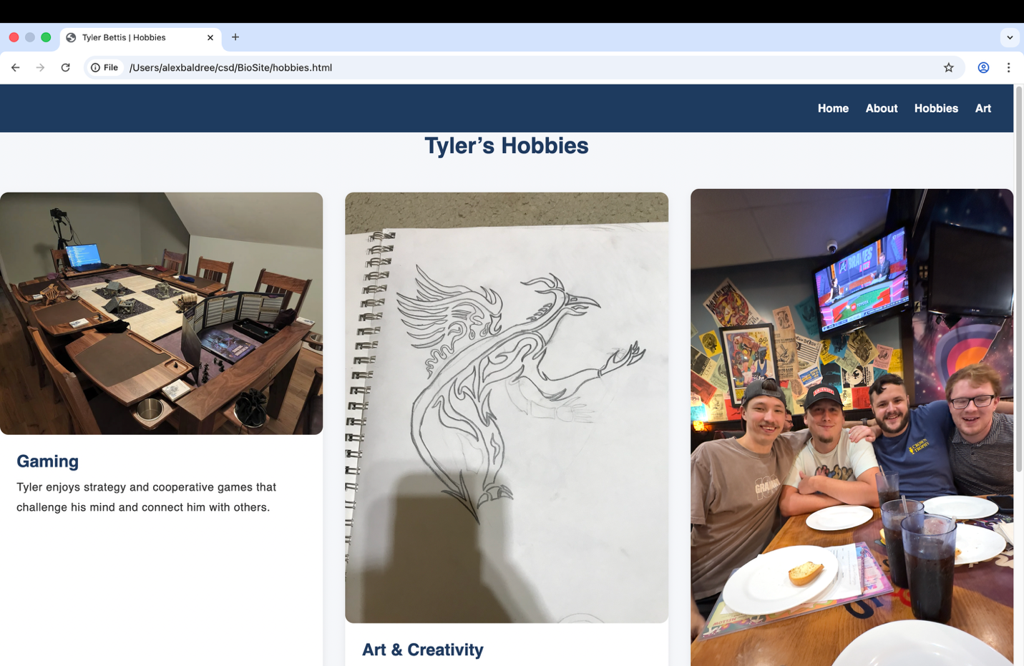

**Tyler’s Hobbies: A couple Hobbies that he enjoys**

**Tyler’s Artwork: Just some of the stuff that he has made**